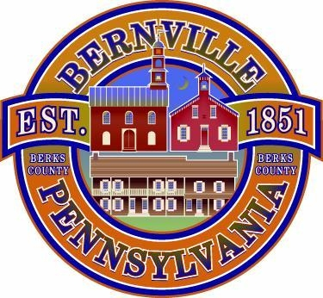

WORKSHOP AGENDA

September 24, 2024

7:00 PM

Call to Order: By:
- Pledge to the Flag
- Announcements
  - The meeting is being Audio Recorded.
  - Guests in attendance must register on the sign-in form.
  - Eligibility to make Public Comments is limited to Bernville Borough Residents or Taxpayers
- Public Comment: Related to Agenda Items Only at this time. Time Limit: 3 minutes per speaker.
- Open Items for Discussion:
  - New Employee – Budget
  - 2025 Budget
  - Progress of New Well feasibility
  - Engineering Interviews
  - Property Maintenance Code
  - LSA Grants
  - Demo Bid Updates
  - Roving Gangs
  - Tax Credit for Volunteer Firefighters
  - ARRO – Tank Inspection
  - Southern Environmental Contract
  - Storm Drains
- New Items for discussion.
- Public Comment: Non-agenda Items. Time Limit: 3 minutes per speaker
- Adjournment: Time Adjourned: _______, Motion By: ____________, Second By: __________

EXECUTIVE SESSION DOCUMENTATION TO BE REFLECTED IN THE MINUTES:
- Where in the Agenda: Purpose: Time Entered: Time Ended:
- Provide Separate Documentation for Each Executive Session.

